String Functions in SQL

✅ Definition
String functions are built-in SQL functions used to manipulate, search, or format text values (strings).

✅ Why use them?
- Clean messy text data (remove spaces, unwanted chars).
- Standardize values (UPPER/LOWER for comparison).
- Extract useful parts (e.g., first name from full name).
- Format outputs for reports (concatenating name + ID, etc.).

✅ Where used?
- Data cleaning (ETL jobs, reports).
- Searching (find keywords inside text).
- Formatting reports (proper case names, IDs with prefix).
- Business logic (generate emails, usernames).

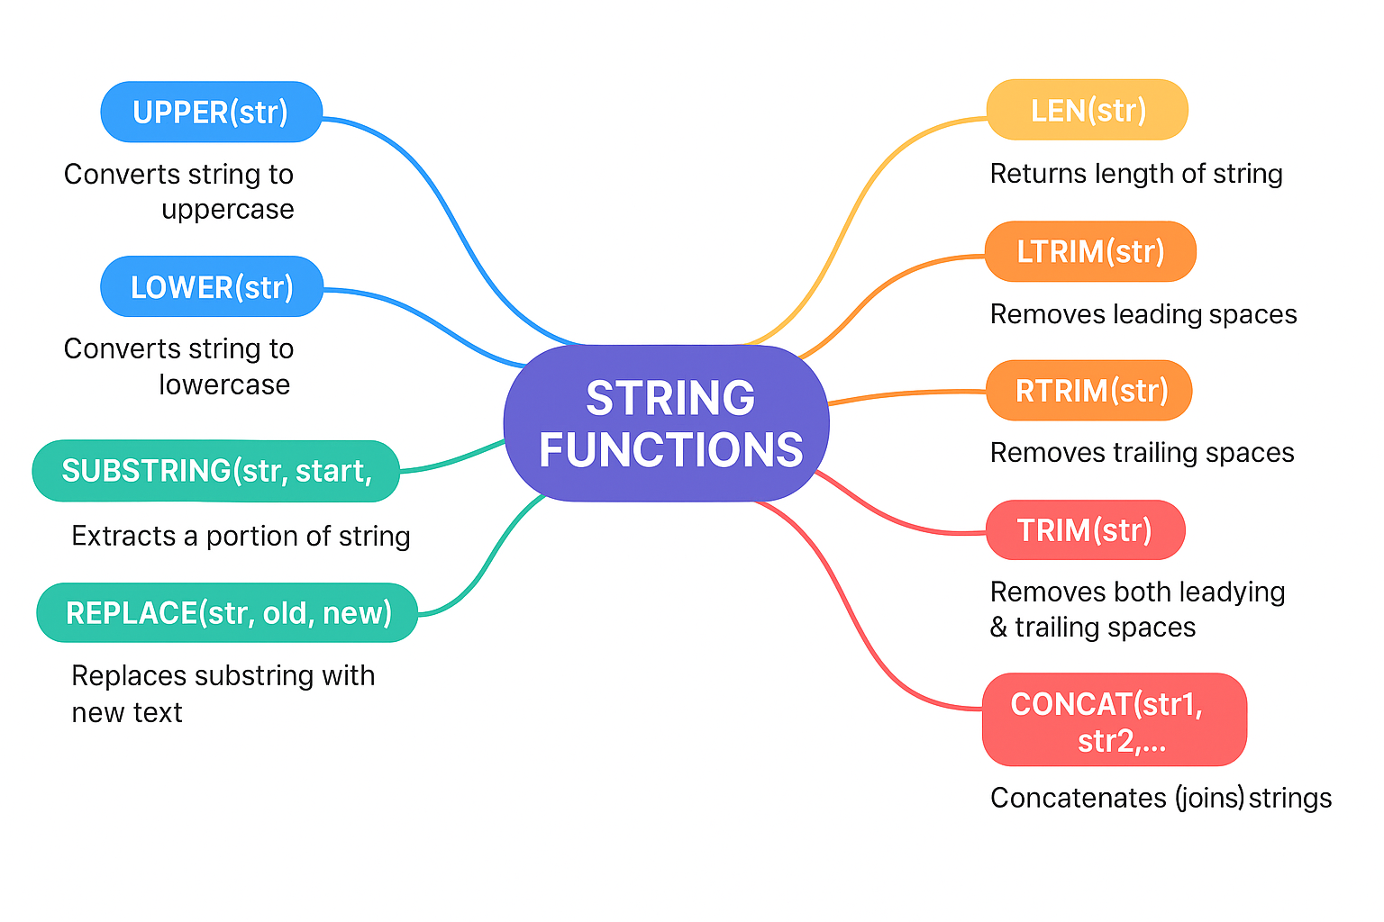
📘 String Functions in SQL
Function | What it Does
UPPER(str) | Converts string to uppercase
LOWER(str) | Converts string to lowercase
LEN(str) (or LENGTH) | Returns length of string
LTRIM(str) | Removes leading spaces
RTRIM(str) | Removes trailing spaces
TRIM(str) | Removes both leading & trailing spaces
SUBSTRING(str, start, len) | Extracts a portion of string
LEFT(str, n) | Returns leftmost n characters
RIGHT(str, n) | Returns rightmost n characters
CHARINDEX(substr, str) (or INSTR) | Finds position of substring
REPLACE(str, old, new) | Replaces substring with new text
CONCAT(str1, str2, …) | Concatenates (joins) strings
REPLICATE(str, n) | Repeats string n times
REVERSE(str) | Reverses the string
SPACE(n) | Returns a string of n spaces
STUFF(str, start, len, newstr) (SQL Server) | Deletes part of a string & inserts new one
ASCII(char) | Returns ASCII code of character
CHAR(ascii) | Returns character from ASCII code
PATINDEX(pattern, str) | Returns position of pattern (like CHARINDEX but with wildcards)

Example for Each
SELECT
UPPER('hello') AS upper_case, -- HELLO
LOWER('HELLO') AS lower_case, -- hello
LEN('SQL') AS length, -- 3
LTRIM(' sql') AS ltrim, -- "sql"
RTRIM('sql ') AS rtrim, -- "sql"
TRIM(' sql ') AS trim, -- "sql"
SUBSTRING('Database',1,4) AS sub_str,-- "Data"
LEFT('Database',4) AS left_str, -- "Data"
RIGHT('Database',4) AS right_str, -- "base"
CHARINDEX('a','Database') AS pos, -- 2
REPLACE('I like Java','Java','SQL') AS replaced, -- "I like SQL"
CONCAT('Hello',' ','World') AS concat, -- "Hello World"
REPLICATE('SQL',3) AS replicated, -- "SQLSQLSQL"
REVERSE('SQL') AS reversed, -- "LQS"
SPACE(5) AS space_str, -- " "
STUFF('HelloWorld',6,5,'SQL') AS stuff_str, -- "HelloSQL"
ASCII('A') AS ascii_val, -- 65
CHAR(65) AS char_val; -- "A"

Real time example:

use MyFirstDB

CREATE TABLE Employees2 (
EmpID INT,
EmpName VARCHAR(50),
City VARCHAR(50)
);

INSERT INTO Employees2 VALUES
(1, 'Alice Johnson', 'Chennai'),
(2, 'Bob Smith', 'Bangalore'),
(3, 'Charlie Brown', 'Delhi'),
(4, 'David Miller', 'Hyderabad'),
(5, 'Emma Watson', 'Mumbai');

1. LEN / LENGTH → returns length of string
SELECT EmpName, LEN(EmpName) AS NameLength FROM Employees;
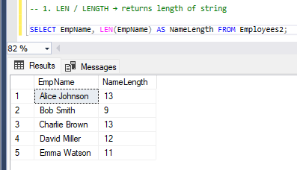
Output
EmpName | NameLength
Alice Johnson | 13
Bob Smith | 9
Charlie Brown | 13
📌 Real use: Check if a phone number has 10 digits.

2. UPPER → convert to uppercase
SELECT EmpName, UPPER(EmpName) AS UpperName FROM Employees;
Output
EmpName | UpperName
Alice Johnson | ALICE JOHNSON
📌 Use: To standardize names before comparing.
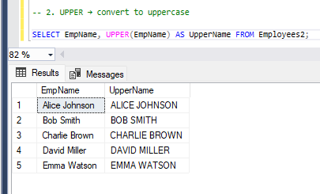

3. LOWER → convert to lowercase
SELECT City, LOWER(City) AS LowerCity FROM Employees;
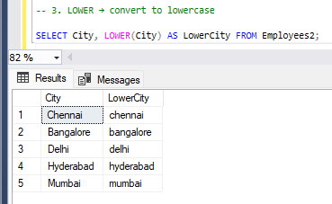
Output
City | LowerCity
Chennai | chennai
📌 Use: Case-insensitive search in emails/usernames.

4. LTRIM / RTRIM / TRIM → remove spaces
SELECT LTRIM(' Hello') AS NoLeftSpaces,
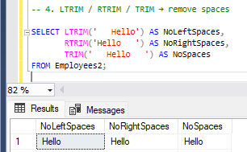
RTRIM('Hello ') AS NoRightSpaces,
TRIM(' Hello ') AS NoSpaces;
Output
NoLeftSpaces | NoRightSpaces | NoSpaces
ello | Hello | Hello
📌 Use: Clean user input data.

5. SUBSTRING → extract part of string
SELECT EmpName, SUBSTRING(EmpName, 1, 5) AS First5Chars FROM Employees;
Output
EmpName | First5Chars
Alice Johnson | Alice
Bob Smith | Bob S
📌 Use: Extract year from YYYY-MM-DD date stored as text.

6. LEFT / RIGHT → get characters from left/right
SELECT EmpName, LEFT(EmpName, 3) AS Left3, RIGHT(EmpName, 4) AS Right4 FROM Employees;
Output
EmpName | Left3 | Right4
Alice Johnson | Ali | son
Bob Smith | Bob | mith
📌 Use: Extract area code from phone number.

7. REPLACE → replace part of string
SELECT EmpName, REPLACE(EmpName, ' ', '_') AS UserID FROM Employees;
Output
EmpName | UserID
Alice Johnson | Alice_Johnson
📌 Use: Replace spaces with underscores for usernames.

8. CONCAT / + (SQL Server) → combine strings
SELECT CONCAT(EmpName, ' - ', City) AS EmpDetails FROM Employees;
Output
EmpDetails
Alice Johnson - Chennai
Bob Smith - Bangalore
📌 Use: Display full details in one column.

9. CHARINDEX / INSTR → find position of substring
SELECT EmpName, CHARINDEX(' ', EmpName) AS SpacePos FROM Employees;
Output
EmpName | SpacePos
Alice Johnson | 6
Bob Smith | 4
📌 Use: Find where first name ends.

10. REVERSE → reverse string
SELECT EmpName, REVERSE(EmpName) AS RevName FROM Employees;
Output
EmpName | RevName
Alice Johnson | nosnhoJ ecilA
📌 Use: Palindrome checks, string processing.
✅ These are the top 10 most used string functions in real life

